**Feasibility analysis of the GoSafe:**

The objective of feasibility analysis is to get to know the requirement of an web app which is platform meets cab service providers and all kinds of people.

**People’s opinions, their suggestions about GOSAFE:**

Online survey revealed the necessity of our Gosafe web application. Sharing feature adds up a lot to our product and the response as you can see is admirable 98% clients deeply need sharing feature. We received great info about their requirements that can be solved through our Gosafe. They related this product with Ola and Uber which is a supportive and encouraging spirit for our initiative. As we are only preparing online web app there is no much loss of money.

**Pie charts of responses received:**

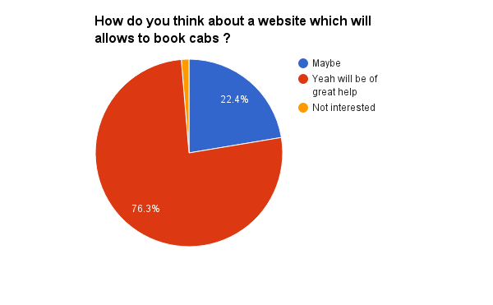

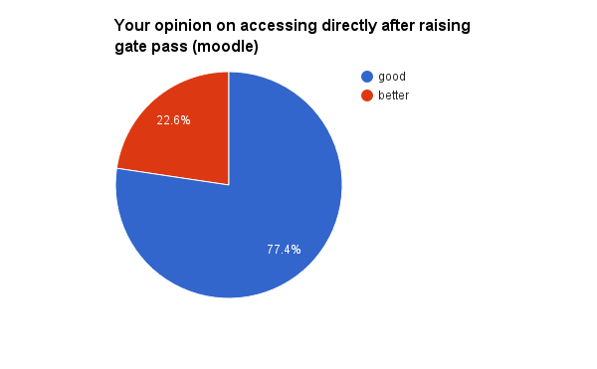 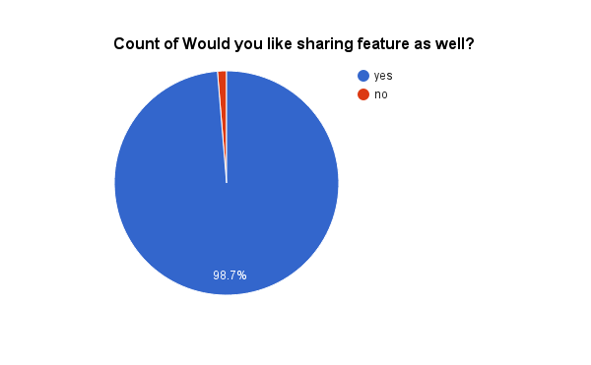 **Few suggestions:** Some of their requirements are payment gateway to be included which removes problem of amount to be paid, asked it to get access from the moodle system, so that the moment the gate pass gets approved they can book a cab. Which will also increase the number of users to our site. But these two are time taking and work related issues. Hence taken into consideration and these features will be added in further versions.